Hotel Indigo debuts in Melbourne
Pro-invest Group opens doors to Hotel Indigo Melbourne on Flinders
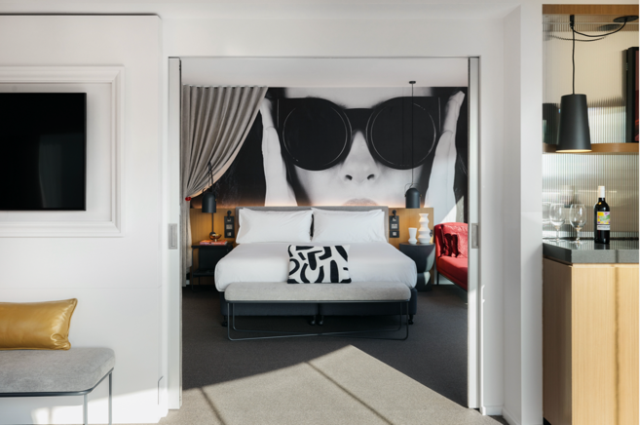
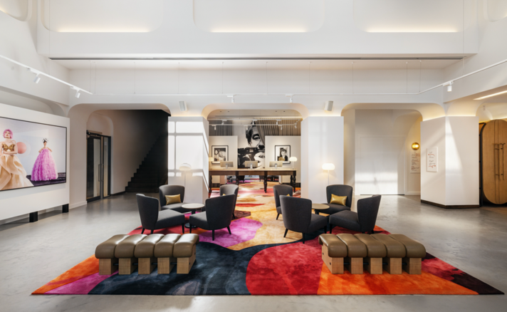

For immediate release / 21 August 2023: Pro-invest Group and IHG Hotels & Resorts announce the opening of Hotel Indigo Melbourne on Flinders today, bringing a new style of boutique hotel to the city.

The unveiling of the hotel on Flinders Lane debuts the global Hotel Indigo brand in Melbourne thanks to
Pro-invest Group’s acquisition of the property, formerly operating as a Holiday Inn, and their sweeping $20million refurbishment.

Now a creatively curated lifestyle boutique hotel, the 216-room property’s exciting reinvention has been inspired by the history and colourful legends of its Flinders Lane neighbourhood, primarily internationally acclaimed fashion photographer Helmut Newton whose original studio was nearby.

With Newton’s work as muse, fashion, art and runway combine to invite guests into an enclave of collected and commissioned photographic artwork, starting with a dramatic lobby-gallery space and lounge – there’s even a specially designed selfie booth for guests to capture their own Newton-esque memory.

A ‘lights, camera, action’ themed design by Suede Interiors continues throughout the guest rooms that feature more local artists’ commissioned works and dynamic city views across a patchwork of heritage and new buildings. Biology care amenities, Seed & Sprout bathrobes and spacious work desks will keep guests comfortable; while Melbourne’s Cartel coffee and breakfast served in the lounge will fuel guests for a day of discovery, aided by city guides prepared by the hotel team. A mezzanine level fitness centre (opening October) with body-weight powered equipment adds to the hotel’s sustainable credentials and stylish meeting and event facilities for up to 200 guests will be complete in early 2024.

Guests won’t need to wander far to discover the city’s renowned dining, with the opening of new streetside Spanish taperia, bar and restaurant BESO housed within Hotel Indigo Melbourne on Flinders.

Helmed by Ana Cortes Garcia, a Spaniard with vast international experience and a Melbourne Chef’s Hat accolade, diners will be challenged by contemporary twists on traditional Spanish tapas. Local hospitality industry stalwart, Guy Holder, directs the offering, including a vibrant list of Victorian and Spanish wines.
More…/ 2

Uncovering more of the city’s laneway culture of street art, hidden cafés, bars, boutiques and galleries starts right from the hotel’s doorstep on Flinders Lane, while exploring the neighbourhood further will reveal major entertainment, sport and cultural attractions. Etihad Stadium, Melbourne Convention & Exhibition Centre and Southbank precinct are an easy walk – and Southern Cross Station is within arms-reach for those travelling further afield.

Jan Smits, CEO, Asia Pacific of Pro-invest Group said of the hotel opening: “Our multi-million-dollar investment has successfully transformed this exceptional property to introduce Hotel Indigo's vibrant spirit to Melbourne.

“With the dynamic Flinders Lane setting, creative interiors and our welcoming team lead by General Manager, Joseph Simmons, we believe Hotel Indigo Melbourne on Flinders will captivate and inspire curious guests looking to enjoy the city in new ways,” he adds.

Hotel Indigo Melbourne is Pro-invest Group’s sixth hotel in the city and the second Hotel Indigo in the company’s portfolio, joining Hotel Indigo Brisbane City Centre. The company will open its third - Hotel Indigo Sydney Potts Point - later this year. Pro-invest Group is IHG’s largest franchise partner across Australasia with an extensive estate of Holiday Inn Express hotels, as well as recent openings under the Kimpton and voco brands.

Matt Tripolone, Managing Director - Australasia & Pacific at IHG Hotels & Resorts, said: “We are so pleased to see our franchise partnership with Pro-invest Group go from strength to strength with the opening of Hotel Indigo Melbourne on Flinders. It continues the growth we’ve had together across the IHG portfolio and the huge momentum behind the Hotel Indigo brand in Australasia and around the world.”

With 273 open or pipeline hotels globally, Hotel Indigo is one of the world’s leading boutique premium brands that provide a gateway to discover some of the most inspiring cities. Each Hotel Indigo draws inspiration from the local neighbourhood, culture and popular trends in food, drink and design to create a warm and vibrant atmosphere.

Hotel Indigo Melbourne on Flinders
575 Flinders Lane, Melbourne
Australia
hotelindigo.com/melflinders

-ENDS-

For media information contact:
Susan Wright / Q Strategies
P: +61 421 007 200 E: susan@qstrategies.com.au

First look images available here

About Pro-invest Group
Established in 2010, Pro-invest Group invests in hotels and commercial property assets on behalf of global institutional investors across Europe, Middle East and the APAC region.

Pro-invest Group manages c. AUD$3 billion in assets under management through a combination of discretionary funds, joint ventures, and managed accounts. Pro-invest Group’s integrated platform spans the asset lifecycle, from arranging funding through to developing, operating and asset managing individual assets as well as portfolios.

Pro-invest Group assets include 31 hotels (approx. 6,000 rooms – open and pipeline) in Australia and New Zealand, in addition to commercial and mixed-use properties. Having established itself as a management platform in Australasia, the Pro-invest Group London office was established to focus on growth in the UK and Europe. Simultaneously Pro-invest Group are raising a third value-add fund of A$500 million for opportunistic investment in Asia-Pacific.
Further information found here www.proinvestgroup.com

About Hotel Indigo:
Just as no places are alike, no two Hotel Indigo properties are alike. Each Hotel Indigo draws inspiration from the local neighbourhood, culture and popular trends in food, drink and design to create a warm and vibrant atmosphere. Our hotels provide a gateway to discover and explore some of the world’s most inspiring cities and neighbourhoods. For more information, visit www.hotelindigo.com, and connect with us on Facebook www.facebook.com/Hotel.Indigo, Twitter www.twitter.com/hotelindigo, and Instagram www.instagram.com/hotelindigo.

