Press Release

Primevest Capital Partners closes third deal in Spain with residential development acquisition in Albacete for German pension fund

Utrecht/Berlin, 6 March 2023 – Pan-European investment manager Primevest Capital Partners (Primevest CP) has acquired an 8,755 m² residential development in the city centre of Albacete, about 200 km southeast of Madrid, for approx. €21 million on behalf of a German pension fund. The six-storey property, comprising 127 rental apartments, was purchased from developer Grupo Albaluz, part of Tracia Ventures y Moreno Brothers Capital.
Olaf Steinbusch, Senior Acquisition Manager at Primevest Capital Partners, said: “Our third residential acquisition in Spain is completely in line with our investor’s investment strategy for the country. The development represents a solid investment opportunity on an A location in the capital of the Spanish province of Albacete, thanks to its proximity to the old city centre and other amenities as well as its high technical and sustainability standards.”
The scheme is located on the corner of Calle Alcalde Conangla 3 and Calle Serreriá in the city centre of Albacete, and the historic old town is within walking distance. The ‘Albacenter’ shopping centre is only 300 metres away, alongside shops, bars and restaurants while a primary and secondary school and one of the city’s three universities are also close by. The property has good public transport connections: a bus stop is located directly at the building’s doorstep and the main railway station can be reached within a 10-minute walk. Nearby port cities include Valencia in the east, and Alicante and Cartagena to the southeast. The city’s connection to the Spanish AVE high-speed train means Madrid is accessible within 1.5 hours and Valencia within 50 minutes. Albacete’s three universities have a total of around 10,000 students.
The 127 residential units range in size between 52 m² and 128 m², and are planned over five floors, while an underground car park will offer one parking space for each apartment. Each flat will have its own terrace or balcony and an individual storage room in the basement while four bicycle storage rooms for up to 100 bicycles will be installed on the ground floor. Residents will also have access to an outdoor pool and a gym situated on the ground floor.
The apartments will be equipped with LED lighting, floor heating, air-conditioning and well-dimensioned windows with external sun protection. The property, scheduled for delivery in the summer of 2025, is being built in line with EU requirements and will have an A energy label, the highest possible rating.
Sebastian Moreno, CEO at Grupo Albaluz, added: “Grupo Albaluz aims to allow every citizen in Albacete to enjoy affordable and high-quality housing. This new development will help meet this goal by stimulating Albacete’s rental market and is a great step forward for the city of Albacete and its residents.”

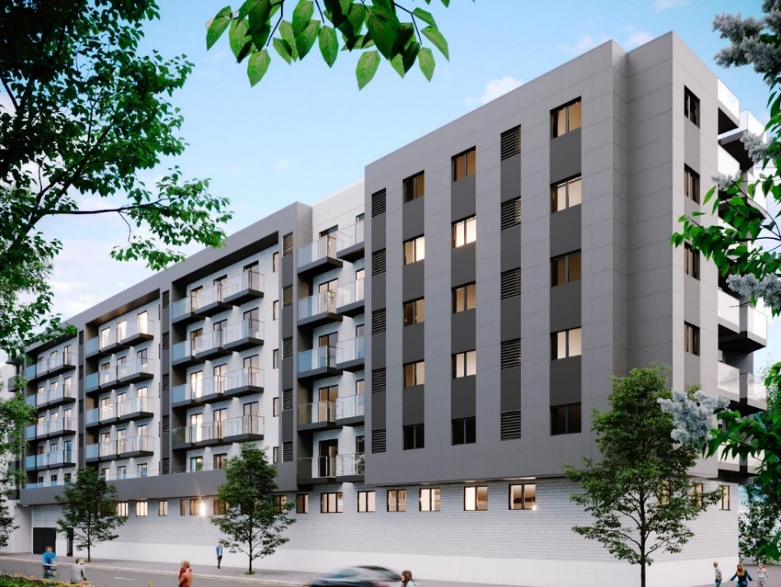
Drees & Sommer acted as technical consultants and CMS Albiñana & Suárez de Lezo as legal advisor for the buyer. Grupo Albaluz was advised by law firm Scasso Abogados.
About Primevest Capital Partners
Primevest Capital Partners is a pan-European investment boutique that specialises in investments in innovative real assets. At Primevest Capital Partners, our vision is to help our clients to provide for their sustainable financial future by investing in the future of our cities in realising sustainable urban living, improving connectivity, and enabling mobility. Our investment philosophy and vision are energised by the current trend of urbanisation and the ability to fulfil the needs of modern metropolitan communities, while enhancing the quality and sustainability of people’s lives.

From our offices in Utrecht, Eindhoven and Berlin, a team of 70 professionals manage €3 billion in real assets across 12 European countries including sector-focused funds, individual institutional mandates and a number of funds targeting private investors as well as family offices following acquisition of the Holland Immo Group. The complementary brands joined forces in 2021 to grow their market position, network and to strengthen each other. Through this combine, we are able to provide a sustainable financial future to a larger and more diverse client base. The group has initiated a total of over 60 funds, of which 32 are currently active. Primevest Capital Partners is part of Primevest Capital Partners Holding B.V.

For more information, please contact:
Primevest Capital Partners
Lisette van der Ham
Head of Marketing & Corporate Communications
T: +31 6 832 005 61
lisette.vanderham@primevestcp.com
www.primevestcp.com

About Grupo Albaluz
Grupo Albaluz is a group of companies active in construction, sales, and real estate development. It was founded by two young entrepreneurs - Dimas de Andrés and Sebastián Moreno – who together have built more than 1,500 homes since 2013, mainly in Albacete city, Valencia, Alicante as well as the province of Catalonia and other areas in Spain. Albaluz plans to start construction and deliver 1,048 homes during 2023-2025.
More information via: https://www.albaluz.es or info@albaluz.es

