90 PERCENT OF THE LARGEST DUTCH RESIDENTIAL DEVELOPMENT IN AMSTERDAM LEASED OUT

- East House in OurDomain Amsterdam South East completed and almost fully let
- Largest residential complex in the Netherlands to be completed in the first half of 2021
- Rental homes in the first building partly allocated to specific target groups

AMSTERDAM, 31 August 2020 – Greystar, global leader in the investment, development and management of high-quality rental housing properties, leased 90% of all of the 955 fully furnished rental apartments in East House, the first building section completed of OurDomain Amsterdam South East. Half of this is leased to students currently moving in right before the start of the academic year. The other half is let to young professionals. OurDomain Amsterdam South East is located right next to Holendrecht train station opposite the Amsterdam UMC.

A large part of the apartments in East House, the completed and almost fully let building section, are part of the regulated housing segment in the Netherlands. Following the completion of the North and West House buildings in the first half of 2021, this modern, sustainable and largest residential complex in the Netherlands comprises a total of 1,559 rental apartments ranging from furnished studios to high-quality finished apartments for (young) professionals, couples, students and house sharers.

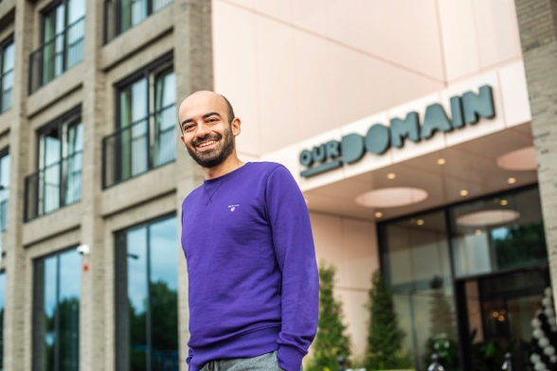 | 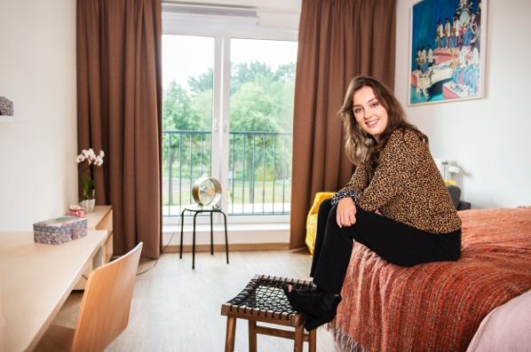
“As an expat, living in OurDomain gives me the best opportunity to quickly meet other people as the concept highly focuses on social interaction amongst residents.” - Aykut Onar | “OurDomain provides a modern, urban style of living. All you need at your fingertips and only a two minutes’ walk from Amsterdam UMC where I study.” - Doris Dijkman

Mark Kuijpers, managing director Greystar Netherlands: “We are very proud of this transformation project we are realising in this part of Amsterdam Southeast together with the municipality. OurDomain gives this area a huge impulse while answering the demand for futurproof and modern living concepts in particular for young professionals and students.”
OurDomain Amsterdam South East services diverse target audiences with a modern and comfortable living environment that answers contemporary housing needs. The residents have access to a wide range of shared facilities and services such as a staffed service desk, 24/7 security, lounges, work / study areas, home cinema room, music room, laundry, game room, parking garage with shared electric mobility, superfast internet, terraces and a green city park. The plinth of the complex will include a gym, a supermarket, catering and a GP practice.

As part of the societal sustainability strategy and inclusion ambitions, approximately one-third of homes have been priority-let to people who:
• already lived in Amsterdam Southeast;
• are affiliated with the Amsterdam UMC;
• work in healthcare or education and are on the municipal waiting list for a home;
• are status holders.

The three buildings of OurDomain Amsterdam South East are connected by a green city park. The complex is the flagship of the extensive transformation Amstel III area in Amsterdam Southeast will see in the coming years.

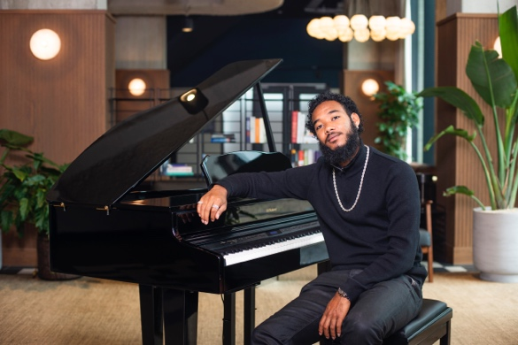 | 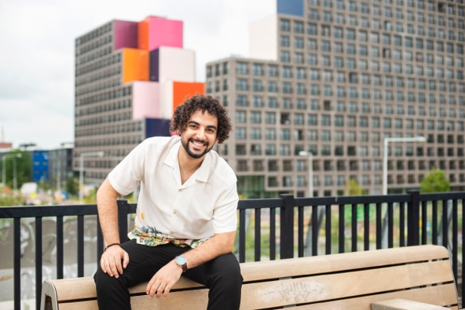
“I grew up in Southeast and always very active in the neighbourhood. Thanks to OurDomain I can continue to live in this neighbourhood and therefor continue to mean something for this district.” – Ryan Pinas | “OurDomain provides the perfect combination of the fun and hustle and bustle of the city dynamics with the calmness of my own home.” - Nouraldeen Hassan Abdulraof Ammar

East House studio’s
All 955 studios in East House are fully furnished and equipped with a modern kitchen and bathroom. The surface of the apartments varies from 20 m² to 33 m² with a basic rent of € 384 to € 785 per month (excluding service charges).

West & North House apartments

OurDomain Amsterdam South East's West & North House comprises 604 high-quality finished 2- and 3-room apartments suitable for singles, couples and house sharers living a modern and urban lifestyle. The lease of the apartments will start in October 2020, rental prices start at €872.

The inner-city redevelopment OurDomain Amsterdam South East is being realised in a partnership between investor and operator Greystar, the municipality of Amsterdam, Blauwhoed and VolkerWessels.

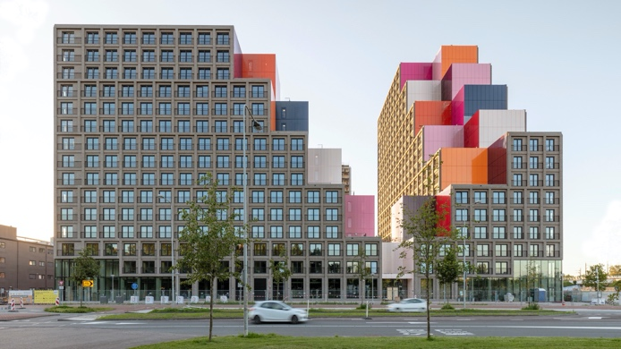 | 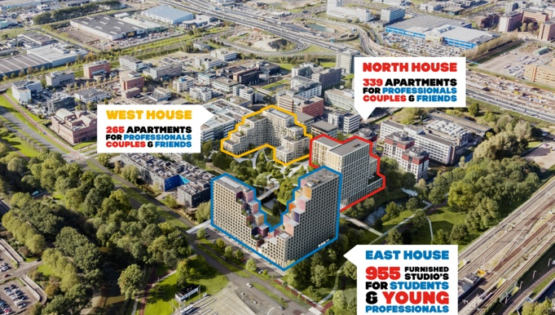
East House OurDomain Amsterdam South East | Birdeyview OurDomain Amsterdam South East

Registration
Apartments can be directly rented via https://www.thisisourdomain.nl/nl/amsterdam-south-east/locatie. Apartments will be directly assigned to candidates meeting the criteria.
The lease of the studios, two- and three-room private sector apartments in North and West House will launch in October 2020. OurDomain Amsterdam South East will be fully completed in the 1st half of 2021. More information on the apartments can be founde here: https://www.thisisourdomain.nl/nl/amsterdam-south-east/appartementen

//END

