PRESS RELEASE

DEA CAPITAL REAL ESTATE IBERIA ACHIEVES 100% OCCUPANCY

ON ITS VILLAVERDE 10.000SQM LOGISTICS PLATFORM

IN ONLY 5 MONTHS

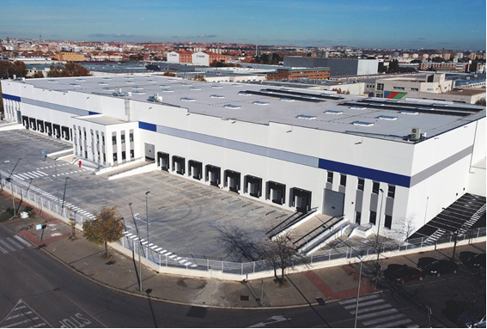

Madrid, 31 July 2023 - DeA Capital Real Estate Iberia has managed to fully lease its new last mile logistics project located in Villaverde (Madrid) just 11 km from the city centre, a prime location for last mile e-commerce distribution operators due to its excellent accesses direct to Madrid centre via main highways and ring-roads including the A-42, M-40, M-45 /A-4 and Av. de Andalucía.

DeA Capital Real Estate Iberia has developed this Class A logistics platform under highest technical and ESG Standards, which has been awarded with the BREEAM Very Good Environmental Certification.

Built on a 14,627 s.q.m plot and with a gross lettable area of approximately 10,000 s.q.m, the asset is divided in 4 modules and counts with 16 loading docks, 12 for trailers and 4 combi docks.

The latest tenant to formalize the lease of the fourth module of 2,450 m² has been Smartee Denti-Technology, a leading manufacturer of digital orthodontic dental solutions worldwide. In this new location, the Shanghai-based company will open its first site in Spain to develop its activity.

The warehouse has reached 100% occupancy in only 5 months after completion, being advised on a co-exclusive basis by Proequity and Colliers. Last February, the tenants Recalvi and Pick & Pack leased the first two modules, and in May the company Humana occupied the third module.

The Villaverde warehouse was the first development project of DeA Capital Real Estate Iberia in the Spanish logistics market within its 2021 co-investment joint venture to develop €150 million in logistics in Spain. DeA Capital Real Estate Iberia has recently completed the construction of a 19,500 sqm logistics platform located in La Atalayuela (Vallecas), and in the coming weeks will start the construction of a turnkey project in Pinto pre-leased to Ecoquímica Logística Integral.

For further information please contact:
Communication and Press DeA Capital S.p.A.
Marco Scopigno, marco.scopigno@deacapital.com,
ph. +39 06 68163206 / 348 0173826
Anna Majocchi, anna.majocchi@deacapital.com
ph. +39 02 62499529 /335 7616715
Communication and Press DeA Capital Real Estate SGR S.p.A.
Beatrice Mori, beatrice.mori@deacapital.com

