PRESS RELEASE

PARTNERS GROUP, DEA CAPITAL REAL ESTATE AND CAMPLUS
FORM NEW PAN-EUROPEAN STUDENT ACCOMMODATION PLATFORM

London, Paris, Madrid, Milan 9 February 2024 - Partners Group, a leading global private markets firm, acting on behalf of its clients, and DeA Capital Real Estate (“DeA”) have formed a new pan-European platform (the "JV") with Camplus, the market leader for student housing in Italy. The JV will develop and operate next generation purpose-built student accommodation (PBSA) assets in Europe and aims to become a market leader in the space, targeting over 5,000 beds.

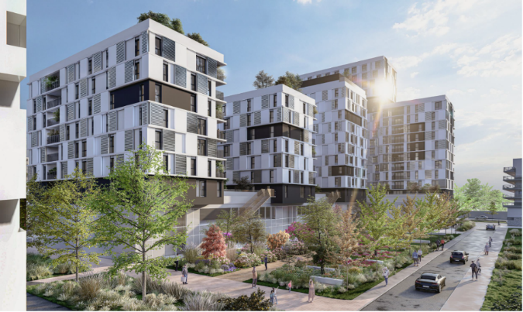 | 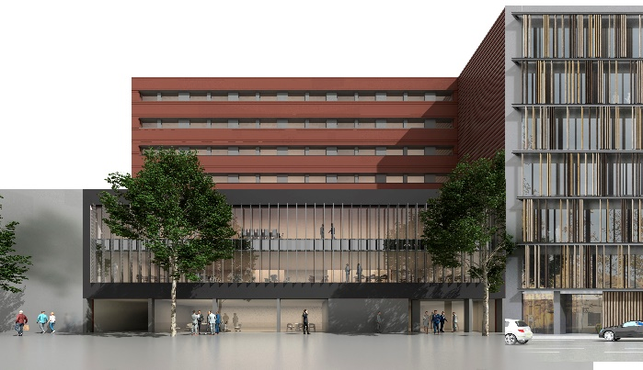
Ivry-sur-Seine, Paris (448 beds) | 22@, Barcelona (250 beds)

The JV will be seeded with two development projects: Camplus Ivry, a 448-bed scheme at Ivry-Sur-Seine, Paris and Camplus 22@, a 250-bed development site in the 22@ technology district in Barcelona. Both projects will be targeting green certifications, including NF HQE Habitat Excellent in France and BREEAM Very Good in Spain, along with WELL and WiredScore certifications. The JV is actively progressing on a significant pipeline of additional projects, with the ambition to build a leading platform of PBSA beds in undersupplied markets across France and Spain.

The JV marks a significant milestone for Partners Group as it continues to build its presence in the student housing sector. This latest JV represents Partners Group's first platform expansion into continental Europe PBSA following its partnership with Host in the UK.

The JV's assets will be operated by Camplus, Italy’s market-leader in student housing, which is renowned for its focus on student experience and customer satisfaction. Camplus' expansion into France and Spain is part of its strategic plan to expand beyond Italy where the firm is the largest provider of student accommodation, managing over 11,000 beds in 16 cities.

Alice Saini, Member of Management Private Real Estate Europe, and Anne-Jan Jager, Managing Director Co-Head Private Real Estate Europe, Partners Group, commented: “The launch of this student housing platform in continental Europe is evidence of our thematic work in action. We have strong conviction in the European student housing sector, especially given the current undersupply of new purpose-built, amenitised student housing in key university cities. We look forward to working with our experienced local partners on building a portfolio of high-quality and sustainable facilities."

Emanuele Caniggia, Chief Executive Officer, and Emanuele Dubini, CIO and head of International, DeA Capital Real Estate, said: "With around 2.9 and 1.6 million students respectively, France and Spain are two of Europe's largest and fastest growing student markets. Demand for student accommodation remains structurally underpinned by demographic tailwinds. Paris and Barcelona clearly show strong market fundamentals. This strategic JV is of great importance to our international real estate platform."

Maurizio Carvelli, CEO and founder of Camplus, added: "We are proud of the launch of this new strategic partnership with industry leaders such as Partners Group and DeA Capital Real Estate. This is a joint venture that confirms the role of Camplus as a leading player in student housing management. Camplus brings over 30 years of sector expertise and innovation in terms of student experience, customer engagement and support services."

Camplus Ivry will be delivered as part of a wider urban regeneration program by leading French developer Cogedim. The site is located in the Ivry-sur-Seine arrondissement and has an established student population with direct access on public transport to the major university campuses of the Paris 1 Panthéon-Sorbonne University, Université Paris Cité and Paris School of Economics (PSE).

Camplus 22@ is located in the 22@ district, one of the key innovation districts in Europe, benefitting from excellent connectivity to the rest the city and within 15 minutes’ walk from the Pompeu Fabra University (UPF) and other campuses. It will be delivered by local Barcelona developer VOPI4.

About Partners Group
Partners Group is a leading global private markets firm. Since 1996, the firm has invested USD 210 billion in private equity, private real estate, private debt and private infrastructure on behalf of its clients globally. Partners Group seeks to generate attractive returns through capitalizing on thematic growth trends and transforming attractive businesses and assets into market leaders. The firm is a committed, responsible investor and aims to create sustainable returns with lasting, positive impact for all its stakeholders. With USD 147 billion in assets under management as of 31 December 2023, Partners Group provides an innovative range of bespoke client solutions to institutional investors, sovereign wealth funds, family offices and private individuals globally. The firm employs more than 1,900 diverse professionals across 20 offices worldwide and has regional headquarters in Baar-Zug, Switzerland; Denver, USA; and Singapore. It has been listed on the SIX Swiss Exchange since 2006 (symbol: PGHN). For more information, please visit www.partnersgroup.com or follow us on LinkedIn.

About DeA Capital Real Estate
DeA Capital Real Estate is the Italian headquartered Pan-European Investment Management Company, with a network of eight offices and over 180 local experts in Milan, Rome, Paris, Madrid, Warsaw, Munich, Frankfurt and London.
Offering best-in-class pan-European asset management with an experienced and stable senior team, boasting an excellence in acquiring, developing, financing, leasing, managing and disposing of assets. The Company has practical experience in the structuring and managing of investment vehicles, whilst always maintaining its fiduciary responsibility to clients.
DeA Capital Real Estate manages €13.3 bn in assets through 52 real estate vehicles and holds approximately 750 assets predominantly across gateway cities in Europe.

For further information please contact:
Communication and Press DeA Capital S.p.A.
Marco Scopigno, marco.scopigno@deacapital.com
ph. +39 06 68163206 / 348 0173826
Anna Majocchi, anna.majocchi@deacapital.com
ph. +39 02 62499529 /335 7616715
Communication and Press DeA Capital Real Estate SGR S.p.A.
Beatrice Mori, beatrice.mori@deacapital.com

About Camplus
The Camplus network is the largest provider of housing for university students in Italy and proposes flexible and differentiated solutions to meet every need: university merit colleges, A network of 11 colleges of merit recognised and accredited by the MUR, Ministry of Universities and Research, residences for Italian and international students who seek flexibility and independence but do not want to give up the opportunity to live in a community and flats for university students and young professionals or short-stay solutions for tourists, visiting professors and researchers.
Camplus has been able to extend the hospitality concept to new housing models and to create a true hospitality philosophy capable of combining the needs of the student and the smart traveller. The Camplus network, with its three services - Colleges of Merit, residences, flats - is now present in 15 Italian cities: Milan, Turin, Bologna, Rome, Florence, Ferrara, Palermo, Catania, Parma, Venice, Padua, Cesena, Pavia, Aquila, Verona and in Spain in Pamplona and Seville.

