**Press Release**

**Primevest Capital Partners takes over first residential Build-to-Rent project in Seville from AEDAS Homes**

**Utrecht/Berlin, 25 January 2023 – Primevest Capital Partners took over the first residential Build-to-Rent project in Seville, Spain on behalf of a German pension fund on 21 December 2022. The property measuring 13,000 m² consists of three buildings with 125 residential units and has been developed in the style of a resort. These buildings will provide a new supply to the rental market in Seville.**

Primevest Capital Partners, an investment and asset manager for institutional investors, acquired the property from AEDAS Homes in early 2022. The property was also developed by AEDAS Homes, a leading national housing development company.

**Olaf Steinbusch, Senior Acquisition Manager at Primevest Capital Partners, says:** “This first Build-to-Rent project consolidates our investor’s investment strategy in Spain, which is based on acquiring properties in selected cities throughout the country. We are grateful to Enrique Molina Campos (Alba REIM) for sourcing and brokering this opportunity. Besides Spain, Primevest invests in residential projects and assets in Germany, The Netherlands, Denmark, Austria and in the future also in Italy. In addition Primevest invests in parking assets as well in other European countries such as Norway and UK.”

The property at ‘Jardines Hacienda Rosario’, consists of three buildings with 125 residential units sized between 60 m² and 115 m². There are also two commercial units and includes a parking garage with 196 parking spaces on two levels. All apartments have a storeroom, balcony or terrace, a fitted kitchen and built-in cupboards in all bedrooms. The project has been developed in the style of a resort with two swimming pools, six padel-tennis courts, a football field, basketball courts, a children’s playground, a jogging trail of more than one kilometre, a social club with catering services, large gardens and promenades.

The development has BREEAM certification which indicates high levels of sustainability based on features such as solar panels for electricity generation, heat pump air conditioning (without fossil fuels), rainwater and wastewater collectors, state-of the art LED lighting and a clean point for recycling waste, plastic, glass and paper, which will ensure substantial savings in energy and the economy for future residents.

**Claudia Gerber, Senior Asset Manager at Primevest Capital Partners highlights:** “In the case of Seville, where most of the rented properties are owned by private individuals, this building will provide a new supply, professionally managed and adapted to the rental market, combining many aspects of contemporary, affordable, and sustainable living. There is a high demand for the property due to its design and high quality of the buildings as well as the wide range of possibilities for leisure activities.”

Rental prices start at €600 per month for the 3-bedroom apartments, €700 for the 4-bedroom apartments and €950 for the 5-bedroom apartments, plus service charges. The property management will be handled by MVGM Property Management, one of the leading European property management companies for this type of product. The first tenants will be able to move in at the end of January. The Build-to-Rent project has been named ‘Las Delicias’ in reference to an historic garden in Seville’s city centre and will be marketed under this name.

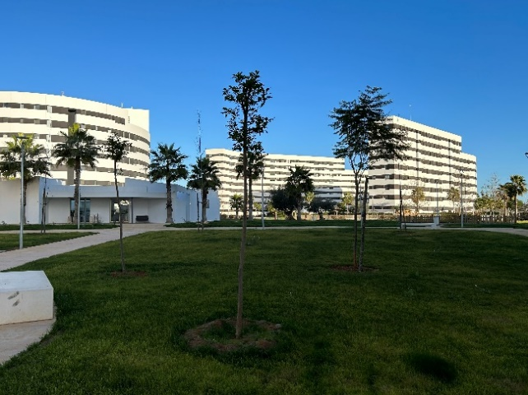

**About Primevest Capital Partners**

Primevest Capital Partners is a pan-European investment boutique that specialises in investments in innovative real assets. At Primevest Capital Partners, our vision is to help our clients to provide for their sustainable financial future by investing in the future of our cities in realising sustainable urban living, improving connectivity, and enabling mobility. Our investment philosophy and vision are energised by the current trend of urbanisation and the ability to fulfil the needs of modern metropolitan communities, while enhancing the quality and sustainability of people’s lives.

From our offices in Utrecht, Eindhoven and Berlin, a team of 70 professionals manage €3 billion in real assets across 12 European countries including sector-focused funds, individual institutional mandates and a number of funds targeting private investors as well as family offices following acquisition of the Holland Immo Group. The complementary brands joined forces in 2021 to grow their market position, network and to strengthen each other. Through this, we are able to provide a sustainable financial future to a larger and more diverse client base. The group initiated a total of over 60 funds, of which 34 are currently active. Primevest Capital Partners is part of Primevest Capital Partners Holding B.V.

**For more information, please contact:**

Primevest Capital Partners

Lisette van der Ham

Head of Marketing & Corporate Communications

T: +31 6 832 005 61

[lisette.vanderham@primevestcp.com](mailto:lisette.vanderham@primevestcp.com)

[www.primevestcp.com](http://www.primevestcp.com)