Media Information
KGAL more than doubles new business to 3.4 billion euros
Grünwald, 22.02.2022 – In the challenging market environment of 2021, KGAL Group succeeded in setting a record with its transactions across its asset classes Real Estate, Sustainable Infrastructure and Aviation. Simultaneously, investors entrusted newly launched funds such as KGAL Wohnen Core 3 and KGAL ESPF 5 with 800 million euros of new equity. The total investment volume managed by the KGAL Group increased from 15.2 to 16.5 billion euros. ESG plays an increasingly important role in the decision to invest with KGAL.

The impact of the Covid-19 pandemic on the economy and capital markets has waned over the course of 2021. However, for institutional investors challenges have by no means diminished. Inflation has been rising, real yields remain deeply negative and a tightening of monetary policy appears imminent. "In this environment, bonds represent a risk with almost no return, while stock market volatility has increased substantially," explains Gert Waltenbauer, CEO of KGAL GmbH & Co. KG. "In contrast, we at KGAL are once again securing attractive, stable cash flows for our investors as a result of the numerous acquisitions over the past year. Furthermore, real assets can offer protection against inflation, for example through indexed rents in Real Estate or rising energy prices in Sustainable Infrastructure."

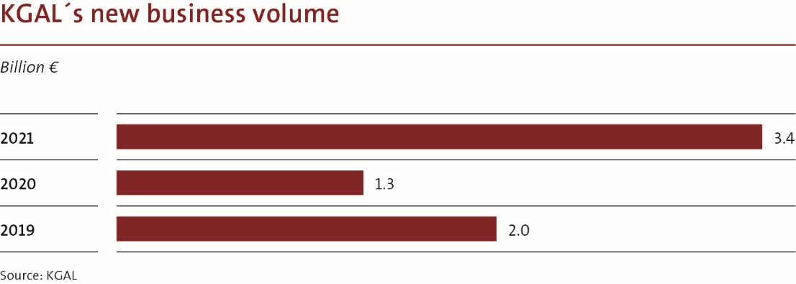

Today, securing commitments for new funds depends not only on their risk-reward profile, but increasingly on having convincing ESG propositions. Mr Waltenbauer continues: "Sustainability is now often at the top of the agenda when talking to investors. We expressly welcome this development." This is why the overview of KGAL's corporate divisions also starts with the topic ESG.
ESG: Impact at company and product level
Since January 2021, KGAL has been a climate-neutral asset manager in relation to its direct business operations by reducing and offsetting CO₂ emissions. Work is underway along the defined "carbon neutral" roadmap to gradually reduce all emissions at KGAL and also within its investment portfolios to net zero. In addition, ESG aspects are being strengthened in all areas of the business, from data collection to risk management and corporate strategy. Given the extraordinary importance of the topic, the ESG Office has been strengthened in terms of personnel and now reports directly to the COO.

Fund management with a pronounced ESG orientation is also only possible if sustainability is at the heart of the company. Following its successes with the ESG-oriented KGAL Wohnen Core 3 and the impact fund KGAL ESPF 5, KGAL is planning to launch two new impact funds over the course of 2022. In addition to a renewable energy fund focusing on green hydrogen technologies, KGAL intends to offer a European residential real estate fund under Article 9 SFDR for the first time.

Real Estate: high pace of capital raising and investment
KGAL Wohnen Core 3, launched in early 2021, has been extremely well received with its clear, research-based investment strategy and pronounced ESG approach. Shortly after the launch, the target equity was increased to the hard cap at 500 million euros and the fund is already closed. Over 70 percent of the total investment volume of approximately one billion euros was allocated within a few months to five residential properties spread across Germany. KGAL has also made several high-quality commercial real estate acquisitions, for example in premium locations of Prague, Brussels, Barcelona and London.

In total, the real estate team completed 15 acquisitions in seven countries in 2021, including transactions in Spain and Belgium for the first time. The internationalisation of the real estate portfolios is progressing well. Real estate assets under management increased by 1.2 to more than 8.3 billion euros, the occupancy rate in the overall portfolio is a remarkable 98.5 percent despite two years of Covid 19 pandemic.

The open-ended mutual real estate fund KGAL immoSUBSTANZ once again achieved an above-average performance of 3.7 per cent in 2021 and, three years after its launch, has generated a first-class total return of 11.5 per cent. Following a positive rating from Scope, KGAL immoSUBSTANZ has now also been rated by FondsConsult for the first time and received a "Buy" recommendation.

Sustainable Infrastructure: Pioneering spirit pays off
Over the course of 2021 wind power and solar power projects with a total capacity of around 1.5 gigawatts entered development, construction or operation. Prior to that KGAL's entire renewable energy portfolio had a capacity of around 1.2 gigawatts. A large proportion of the new projects was accounted for by KGAL ESPF 4, which is now almost completely allocated.

The successor fund, KGAL ESPF 5, is KGAL's first impact fund – one of the few Article 9 products in the market to date. Within a few months of its launch, KGAL was able to achieve its first closing with 260 million euros in equity, more than half of the fund’s target volume. The transaction team has already invested almost 20 percent of the committed capital. Among the initial investments, KGAL ESPF 5 has acquired a 25 percent stake in the successful renewable energy project developer GP JOULE Projects. KGAL ESPF 4 has also acquired a 25 percent stake in GP JOULE Projects. Both funds gain access to an extensive, attractive project pipeline, which will be further expanded in Germany and across Europe, in partnership with GP JOULE.

Aviation: taking advantage of counter-cyclical opportunities
The recovery of the aviation industry in 2021 was less vigorous than hoped due to repeated lockdowns and travel restrictions. However, a return to the growth path should be achievable in the medium term. The aviation team was able to take advantage of the current situation and made a countercyclical investment of two Airbus A320s on attractive terms for the KGAL APF 3 fund. In addition, GOAL, a joint venture between KGAL and Lufthansa, acquired two aircraft for its own balance sheet. Towards the end of the year, KGAL APF 5 was launched as a single account on behalf of a German pension fund. The total investment volume of this aircraft fund is around 150 million euros. KGAL envisages attractive opportunities for aircraft investments in the current market.

Business with Japanese Operating Leases (JOLs) reached record levels. Lufthansa Leasing, another joint venture between KGAL and Lufthansa, financed 20 aircraft for the Lufthansa Group in 2021 with a total volume of 1.6 billion US dollars by way of JOLs.

Human Resources: Expansion and diversity
KGAL anticipates that the appetite for real assets will continue to increase among institutional investors. Due to the expected rise in demand, KGAL intends to significantly increase its employee base from the current 338.

The management team attaches great importance to a corporate culture characterised by diversity. In 2020, KGAL adopted a Diversity and Inclusion Policy and since 2021 the company regularly reviews the progress and success of the policy. Equal opportunities and diversity at all levels within an organisation, are as essential as experience and expertise for successful asset management in the future.

When using the images, please quote KGAL GmbH & Co. KG.
KGAL is a leading independent investment and asset manager with a managed investment volume of more than €16.5 billion. The group sources, executes and manages long-term real asset investments for institutional and private investors in real estate, sustainable infrastructure and aviation. KGAL, which operates throughout Europe, was founded more than 50 years ago and is headquartered in Grünwald near Munich. Our 338 employees are dedicated to achieving sustainable, stable investment performance, taking into account return and risk criteria. (as of 31 December 2021)

