
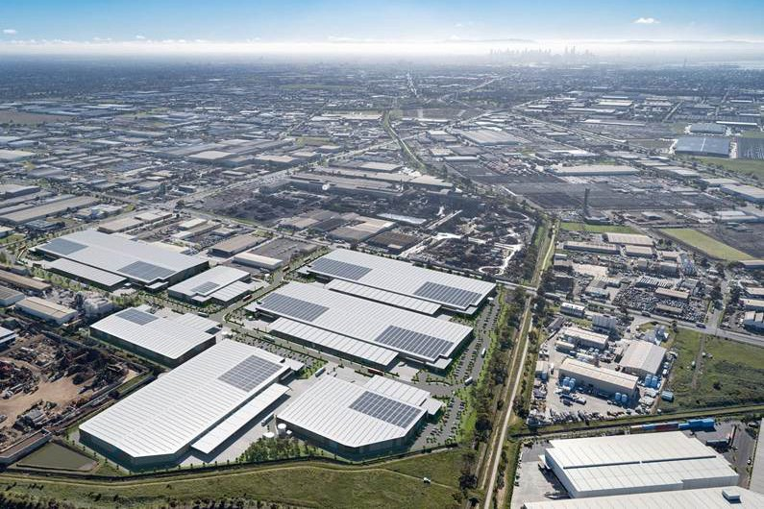

Charter Hall partners with Mitsubishi Estate Asia to develop 40,000sqm state-of-the-art industrial & logistics facility in Melbourne’s core inner-west

12 February 2026 - Charter Hall Group (Charter Hall or the Group) is pleased to announce that it has established a joint venture (JV) partnership between its $14 billion flagship industrial & logistics fund, CPIF, and Mitsubishi Estate Asia (MEA), investing through its affiliated entity, MEC Oceania Investment Pty Ltd. Together, the JV partners will deliver a new 40,000 square metres (sqm) state-of-the-art industrial & logistics estate in Melbourne’s prime industrial precinct at Laverton North. The development is the first stage of a broader $500 million estate with development potential of up to 175,000sqm of lettable area.

Located in Melbourne’s core inner-west, Laverton North is a highly sought-after industrial precinct where Charter Hall has a strong existing footprint, with long-term leases to a broad range of major tenant customers, including Woolworths, Coles, ALDI and Australia Post.

Situated on the prime corner of two major industrial arterials, namely Dohertys Road and Fitzgerald Road, only 4km from the West Gate Freeway, the development provides excellent connectivity to major road infrastructure to the Northern, Western and Southeastern markets, as well as the Port of Melbourne.

The development consists of 40,000sqm warehouse space, with flexibility to be divided into two tenancies. The building will host 37m hardstands, 6,600sqm of super awning and a combination of recessed and on-grade docks. Market-leading sustainability initiatives include 400kW of solar, 80,000L of rainwater tanks for recycled water and water and energy efficient fixtures and fittings. The project is targeting a 5 star Green Star rating (Green Star Buildings V1).

Charter Hall Managing Director & Group CEO David Harrison commented, “We are pleased to have established a new partnership with MEA, one of Japan’s largest real estate consortiums with a successful 10-year track record investing in Australia.
Through this partnership, we will deliver a brand new, state-of-the-art facility that strengthens our capacity to service significant tenant customer demand in a tightly held pocket of Western Melbourne.”

MEA’s Head of Australia Mr Yosuke Matsunaga commented, “Charter Hall is a highly respected partner with deep expertise in Australia’s logistics sector, and we are pleased to be collaborating on this prime Laverton North development. The project aligns with MEA’s strategy to expand our investment in Australia through partnerships with leading operators, focusing on high-conviction locations and sustainable assets. We look forward to strengthening our partnership as we deliver this estate.”

Construction commenced in January 2026, with Texco appointed as builders. Practical completion is slated for November 2026.

Charter Hall Group (ASX: CHC) Charter Hall is Australia’s leading fully integrated diversified property investment and funds management group. We use our expertise to access, deploy, manage and invest equity to create value and generate superior returns for our investor customers. We’ve curated a diverse portfolio of high-quality properties across our core sectors – Office, Industrial & Logistics, Retail and Social Infrastructure. With partnerships and financial discipline at the heart of our approach, we create and invest in places that support our customers, people and communities to grow.

Unsubscribe Head Office: Level 20, No.1 Martin Place, Sydney NSW 2000 Australia Contact Us

