

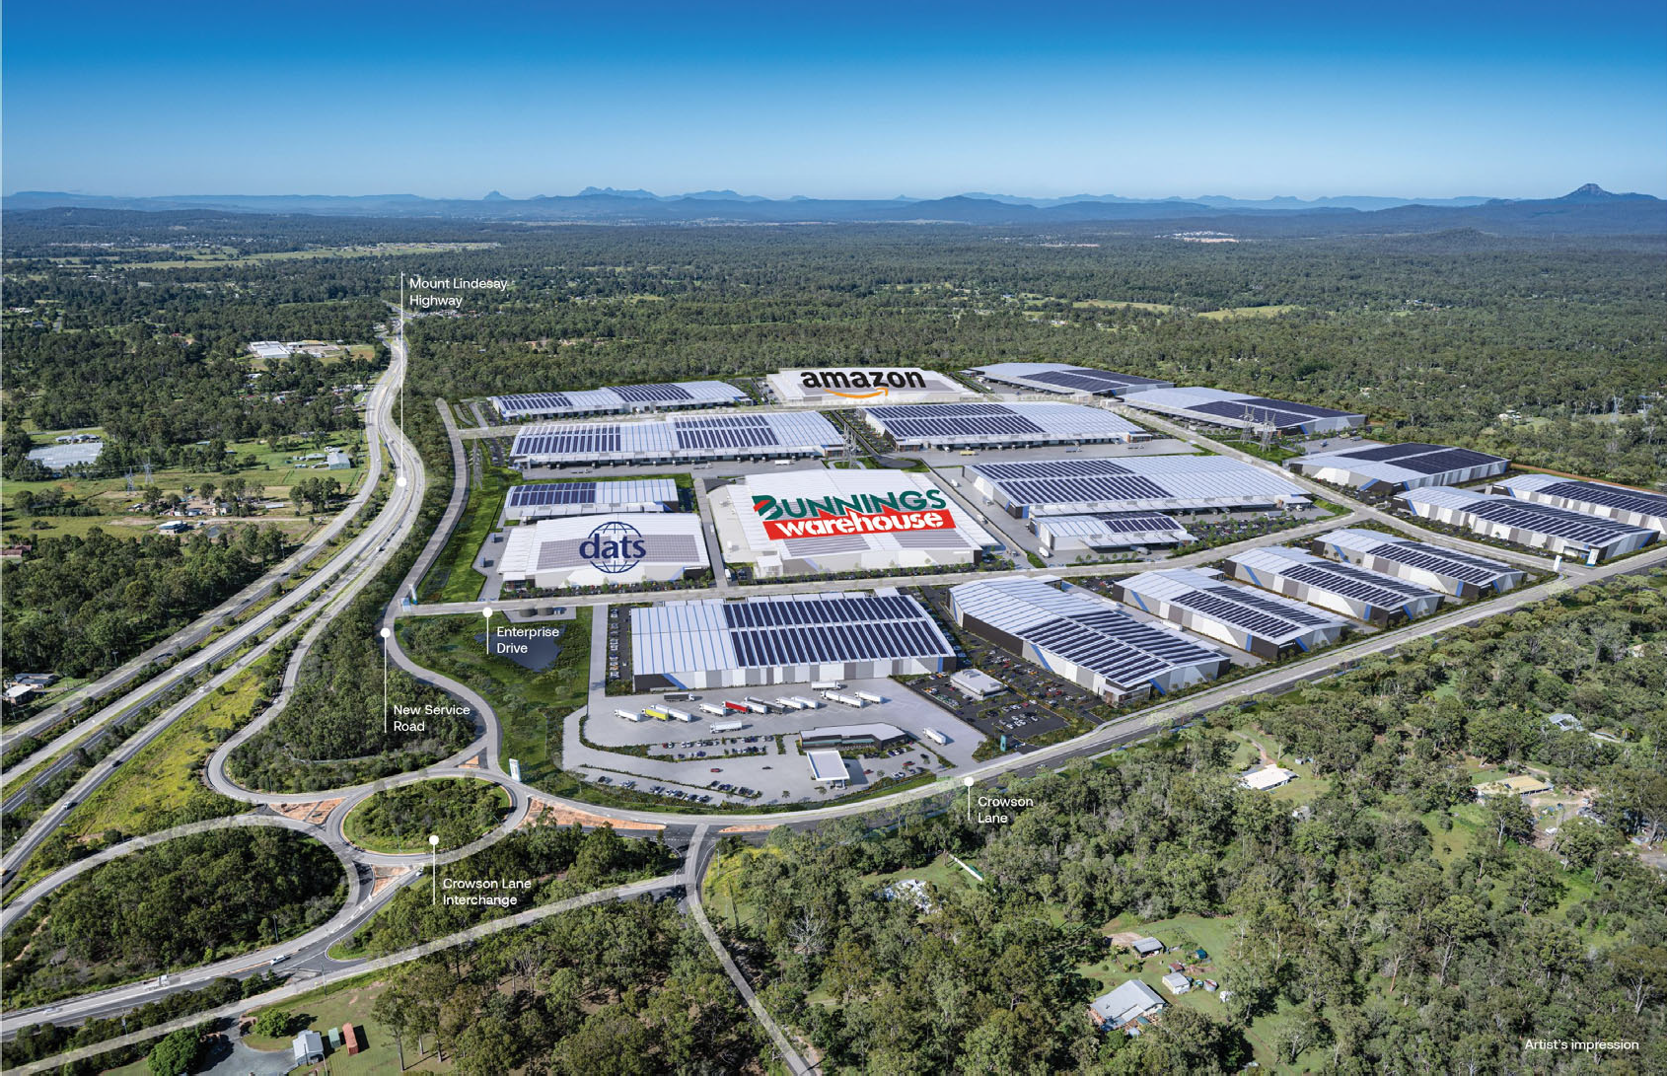

CPIF welcomes Amazon as major tenant customer at Flagstone Logistics Estate in Brisbane
Charter Hall Prime Industrial Fund (CPIF), together with the Charter Hall Group are pleased to announce that it has partnered with Amazon within its Flagstone Logistics Estate (Flagstone or the Estate), joining Bunnings and DATS as a major tenant customer at the premium industrial & logistics estate in North Maclean, Queensland.
Amazon will construct a 150,000 square metre (sqm) multi-level Amazon Robotics Sortable (ARS) fulfillment centre, a first-of-its-kind facility in Brisbane. With 30% of the Brisbane population located within a 15-minute drive of Flagstone, the ARS fulfillment centre will operate as Amazon’s main Brisbane facility, servicing a growing market for the global e-commerce giant.
Charter Hall Managing Director & Group CEO David Harrison commented, “We are

pleased to deepen our partnership with Amazon, who have been a long-standing tenant customer of our Office sector, and to support their growth in the Brisbane region. Their presence at Flagstone, alongside Bunnings and DATS, strongly reinforces the strategic location of this estate as a destination for leading logistics users in Queensland."

30ha of the 118ha Estate are now set to be occupied by blue chip companies, with Bunnings’ 41,000sqm warehouse having reached practical completion in November 2025 and DATS’ 18,500sqm warehouse reaching Practical Completion in March 2026.
Charter Hall Industrial & Logistics CEO Richard Stacker commented, “Flagstone is set to be one of Queensland’s leading industrial estates, with its prime positioning, renewable energy solutions, and the scale and flexibility to meet our tenant customers’ needs. The strength of the tenant covenant already secured underscores this, with leading Australian and global businesses recognising the strategically significant growth opportunity that Flagstone offers."
Access Release

Charter Hall Group (ASX: CHC) Charter Hall is Australia’s leading fully integrated diversified property investment and funds management group. We use our expertise to access, deploy, manage and invest equity to create value and generate superior returns for our investor customers. We’ve curated a diverse portfolio of high-quality properties across
Unsubscribe Contact Us

our core sectors – Office, Industrial & Logistics, Retail and Social Infrastructure. With partnerships and financial discipline at the heart of our approach, we create and invest in places that support our customers, people and communities to grow.

