Save the planet.
Invest (responsibly) in property.

Long term investing in real estate has long been recognised as providing an important role in diversifying risk in a multi-asset portfolio – not only does it offer an attractive level of income but also a degree of inflation hedging. Real estate is a very different asset to Equities and Bonds because it is a physical asset underpinned by land value - as long as it is capable of being used for an economic purpose then it has an intrinsic worth. If a tenant company goes bust, this may have a short term impact on value, but this can be fixed by finding another occupier.

Investors have understood this for years however there has been increased investor interest in the sector post global financial crisis because the onset of quantitative easing has led to yields on all asset classes falling. However real estate yields have not fallen at the same pace and so today, real estate offers an historically high yield premium relative to gilts. This can be seen in the chart below.

Property yield premium versus 10 year gilts

In recent years however a more important issue has been gathering momentum which is not only the wider climate crisis and the various global efforts to slow down the pace of global warming, but also the extent to which the built environment is contributing to this crisis.

Globally it is estimated that real estate - commercial and residential - accounts for c. 40% of all greenhouse gas emissions.

Yet with the lifespan of a typical property measured in decades if not centuries, this almost certainly means that over 80% of the stock of buildings that will exist in 2050 are already built.

What is clear is that management of real estate going forwards needs to change.

The good news is that it is changing. But of course there is a huge amount to do. At Orchard Street we have been building knowledge and experience for over 10 years in how real estate can be designed and built to operate with net zero carbon emissions. Many buildings have been originally built with a good level of operational flexibility which means redevelopment doesn’t have to be the answer – indeed, demolition and re-development both have a high carbon tariff – but imaginative refurbishment programmes can position a property in a way that materially reduces energy use whilst ensuring renewable sources of energy provide heating/cooling and wider energy needs.

But it is more complex than just this because owners and occupiers expect more from the properties they own, occupy and visit. We spend 90% of our lives indoors and new research is emerging showing the impact that poorly designed and maintained buildings can have on our health and productivity.
Ground-breaking research from Harvard university starkly illustrates the cost of ‘sick’ buildings to society: higher numbers of sick days, lower productivity and lower life expectancy – as illustrated below.

THE IMPACT OF GREEN BUILDNGS ON COGNITIVE FUNCTION
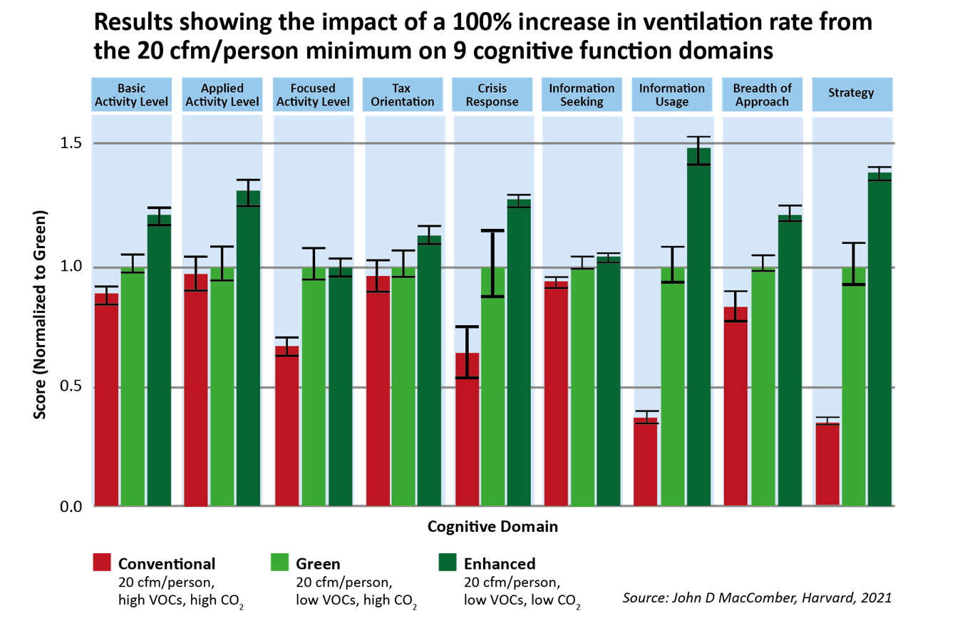

In this study, Harvard goes on to estimate that it can cost up to USD $6,500 per person per annum in a sick building versus a healthy building. When the additional cost of providing a healthy building versus a sick one is just a few dollars more per person per annum, there really is no excuse not to invest a bit more.

The Covid pandemic has brought this health impact even more to the fore and highlighted how much of the current stock of buildings, particularly office buildings, are just not fit for purpose. In some ways, producing a healthy building appears to conflict with traditional thinking which has focussed on insulation and being airtight in order to reduce the cost of heating and cooling.

However, this does not mean that healthy buildings cannot be energy efficient - it just requires more intelligent design and more sophisticated Building Management Systems.

Occupiers of commercial property of course have their own corporate ambitions to limit their own carbon emissions associated with occupying property. Buildings that operate with energy from renewable sources and that can operate on a net zero basis will have an enormous competitive advantage for occupiers. Perhaps of equal importance, occupiers increasingly want to occupy buildings that are healthy, WELL certified with fresh air, outside space, cycle friendly and so on.
And if occupiers only want net zero, healthy buildings, then owners and investors will want to own them. A virtuous circle perhaps but owners (and real estate managers) of real estate that ignore this sea change in attitudes will be left owning and managing real estate that sources energy from non-renewables and that is energy inefficient. Financial under performance beckons.

In our view, all owners and managers of real estate have a responsibility to manage real estate assets proactively given the wider climate crisis and especially given the extent to which real estate is contributing to the problem.

A future proofed commercial property portfolio will therefore comprise buildings that have a long life expectation and can be easily refurbished and adapted to accommodate future occupier needs. If you get that bit right, such a portfolio will produce superior financial performance too.

Warehouse buildings – whether industrial or retail – offer easy pickings with large roof spaces that can accommodate solar PV panels and warehouse space itself that often is unheated. Offices are more complex because of much higher energy usage associated with complex M&E systems but much can still be done.

Indeed we completed a project recently which set out to replace perished carbon steel pipework in a £50m office building in Bristol but which soon evolved into a £3m project which also included upgrades to lighting and air conditioning plant. This has created a substantial reduction in future energy usage in the building with new LED lighting and a hybrid VRF air conditioning system respectively using 70% and 25% less energy. The project cost more than we originally planned but broadening the scope of the project has brought immediate energy saving advantages and contributed to an improvement in the Energy Performance Certificate from Grade C to Grade B. By creating a building offering modern energy efficient space, we have also positioned the property to provide a strong financial performance in the future too.

In another recent office refurbishment - in Manchester - we were able to consider both the energy usage and healthy building agendas. Key to this was an ambitious plan to create and enable the best working environment possible and so whilst we moved the Energy Performance Certificate from a Grade C to Grade A, we also achieved the rare accolade of WELL building certification in 2019.

There are currently only three WELL certified buildings in the UK and this property is the only one to have achieved this certification following a refurbishment. Today the building is best in class with a strong tenant amenity proposition including roof garden, cycle racks with associated showers and a café.

Elsewhere we have recently completed a project on an industrial warehouse property near Leeds. One of the tenants had gone into liquidation leaving a building which required substantial capital expenditure to bring back into shape – the traditional solution would have been repair the roof, give it all a lick of paint and let it, as is, since demand for industrial warehouse units of this type was probably strong enough that enough tenants might overlook the building’s other weaknesses.

A more invasive future proofing of the building would obviously cost significantly more with a new insulated roof and space reconfiguration. However, from our regular engagement with the occupier community on the wider estate we knew the next door tenant was keen to expand into this unit and by designing a project to cover the new roof in solar PV (and selling the power generated to the incoming tenant on a long term power purchase contract at a discount to the price they were paying from the grid), we created a valuable financial outcome even though we invested more in the building than a traditional route might have advocated. We can now look forward to ongoing attractive financial returns coming from a building that has a materially reduced carbon footprint and we have saved the tenant money on their power bill.

Sometimes refurbishment just doesn’t work, as was the case with an obsolete 1930’s industrial estate in west London where we have now created the first ‘carbon neutral in operation’ scheme in London. Whilst the development spend was larger than for a traditional redevelopment, our approach has spotlighted the property ahead of other options for tenants leading to preletting of part, shorter voids on the rest, higher rents and an overall financial outcome significantly ahead of pre project expectations. Prior to the redevelopment, rents for the 1930’s units were in the range £5.50 to £7 per sq ft but afterwards we have achieved in excess of £15 per sq ft and the redevelopment delivered an ungeared IRR in excess of 20%.

All of these examples represent good progress, but we know we can do more. With government regulations on energy usage likely to get more demanding in the future, buildings will need to operate on a net zero basis. Occupiers will want more too, with buildings which can help with staff retention and productivity, rather than hinder it. So managers of real estate will need to consider more than just financial return as they consider the winners and losers in their portfolios.

Orchard Street is currently launching a new Impact Fund which will tackle head on the urgent need to remediate existing UK stock. The Fund will embark on an accelerated programme of creating buildings operating on a net zero basis whilst also creating ‘healthy’ environments within buildings and engaging with local communities to provide a material social contribution for them.

Our Fund is aligned with five selected UNSDGs and Article 9 EU Taxonomy. Our objective is to provide investors with a portfolio of future ‘fit for purpose’ assets capable of delivering an attractive ‘value add’ style return – 12-15% IRR – and after stabilisation, the potential to hold these properties as they will generate long term attractive income returns.

The Fund will acquire, refurbish, repurpose and reposition existing under-utilised real estate in a way that brings positive environmental and social impacts at the local level. Success will be measured against KPIs and will of course be third party assured – because that’s how we define genuine Impact investing and that is what is required.

“The built environment contributes c.40% of the UK’s total carbon footprint, and with the majority of these emissions coming from existing and aging buildings, there is need to decarbonise the existing stock.” . Source: UK GBC

This disturbing statistic highlights to us that as a real estate house we need to do a better job. Indeed, the UK property industry has a responsibility to do a better job - we all need to be more aspirational in the objectives we set for ourselves if we are to achieve better outcomes with the buildings we manage. The built environment touches every member of our society: in the first instance housing provides shelter but it is buildings which provide a place for work and facilities to educate, motivate and rehabilitate. These premises need to be fit for purpose for their users, for their owners and importantly for the community in which they sit.

Orchard Street UK Property Impact Partnership

A responsible real estate investment manager

- 100% of responsible investing targets met in 2020
- First UK refurbished building to receive WELL Gold Shell & Core certification
- First carbon neutral in operation industrial site in west London

Founded in 2004

- We only invest in real estate, c£4bn in AUM*
- 16 years of driving consistent outperformance for our small stable of world class investors
- Strong track record executing investment programmes
- c.£3bn invested over last 7 years and more than £1bn sold
- Partners financially aligned with our clients’ interests
- Single investment committee delivers consistency across all mandates through cycles

- Reputation for shrewd stock selection and forensic asset management

*AUM as at 31 December 2020 and represents the aggregate of the net asset values of client assets under management, measured under the individual client’s reporting GAAP (“Generally Accepted Accounting Principles”), with the addition of undrawn committed capital.

*AUM as at 31 December 2019 and represents the aggregate of the net asset values of client assets under management, measured under the individual client’s reporting GAAP (“Generally Accepted Accounting Principles”), with the addition of undrawn committed capital.

